Anti-EpCAM mIgG2a Antibody(edrecolomab)

Product information
GM-87826AB-10 | 10 μg
GM-87826AB-100 | 100 μg
GM-87826AB-1000 | 1 mg

Antibody Information
Species Reactivity | Human
Clone | edrecolomab
Source/Isotype | Monoclonal Mouse IgG2a, kappa
Application | Flow Cytometry
Target | Detects EpCAM
Gene | EpCAM
Other Names | Ber-Ep4, BerEp4, DIAR5, EGP-2, EGP314, EGP40, ESA, HNPCC8, KS1/4, KSA, LYNCH8, M4S1, MIC18, MK-1, MOC-31, TACSTD1, TROP1
Gene ID | 4072 (Human)
Background | EPCAM (epithelial cell adhesion molecule) gene is an important cell surface protein coding gene, mainly expressed in epithelial cells. EPCAM plays an important role in cell-cell adhesion, signal transduction and cell proliferation, which has attracted extensive attention in the study of various physiological and pathological processes.
Storage | Store at 2-8℃ short term (1-2 weeks).Store at ≤ -20℃ long term. Avoid repeated freeze-thaw.
Formulation | Phosphate-buffered solution, pH 7.2-7.4.
Endotoxin | < 1 EU/mg, determined by LAL gel clotting assay

Data Examples
Flow cytometry | H_EPCAM CHO-K1 Cell Line (Catalog # GM-C19181) was stained with Anti-EpCAM mIgG2a Antibody(edrecolomab) (Catalog # GM-87826AB) or isotype control antibody, followed by anti-Mouse IgG APC-conjugated Secondary Antibody.
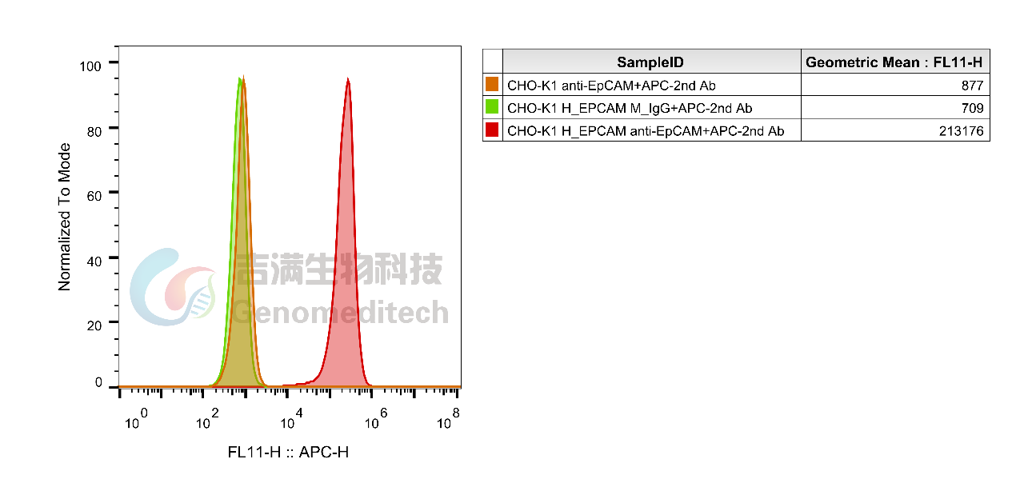
Fig. FACS

